We have a working version on our own git repository so get it from there instead of going through these steps.

-----------------------

To get the project to compile within eclipse:

1. Open eclipse, then navigate to File -> Import …
2. Select Git -> Projects from Git. Then hit next.
3. Select Clone URI. Then hit next.
4. You’ll want to link the IS team’s github repo here. I was only able to get this working by using a link from the web, the downloaded version gave me trouble.
   1. For the URI field, enter this: <https://github.com/ExcaliburSolutions/Grand-Haven-Musical-Fountain.git>
   2. Host: github.com
   3. Repository path: ExcaliburSolutions/Grand-Haven-Musical-Fountain.git

That should be all the info you need to enter, so hit next.

1. If Step 4 worked, you should be given a list of branches to choose from. You probably only need the master branch, but I selected all of them to play it safe. Hit next.
2. Choose a destination to store these files in, I went with the default. Hit next.
3. It will then import the files. This may take a few minutes. Once it has completed, make sure Import Existing Projects is checked, and click next.
4. You’ll be given a list of projects to import. I imported all the projects listed, but you probably only need to select Choreography_Dev here, do it and hit finish.
5. So this next step is a bit of a chore. In your list of projects within eclipse, you should see Choreography_Dev and something like this:

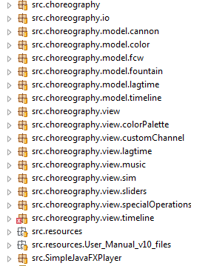

// you may have more packages showing errors than I do here. That’s okay.

however, we need to delete the ‘src.’ from the beginning of each of these package names. If you look in a source file, you’ll notice the package declaration at the top says something like “package choreography”, not “package src.choreography”. If you see errors on every package pop up, this is why. The only way I got this to work correctly was to right click on each one, Refactor, then rename. Delete the ‘src.’ prefix on each package. Once you’ve done that, you should see a lot less errors.

1. At this point, I should note that you will need to link the ControlsFX library to get this to work correctly.
   1. Download ControlsFX libraries.
      1. Link: <http://fxexperience.com/controlsfx/>
   2. Within eclipse, Go to Project -> JavaBuildPath. Select Libraries Tab. Click add external jars. Find the location you downloaded it to and select the controlsfx-8.0.6 jar.
   3. Now click the drop down arrow preceding the jar, and for Native Library Location, add the location path for the folder containing the jar.

e.g:

D:/Installs/eclipse/workspace/GHMF_Project/controlsfx-8.0.6

1. Also, if you see errors on any JavaFX imports, you may need to install eFXclipse.
   1. Follow the instructions at this link: <http://www.eclipse.org/efxclipse/index.html>
2. At this point, you should only see an error on the file within the package choreography.view.specialOperations, called RangeSliderSkin.java. Specifically on lines 140 and 153, both contain the line of code:

new TraversalEngine(rangeSlider, false).trav(rangeSlider, Direction.NEXT);

I haven’t been able to figure out what’s going on with this code, so I just commented both

out. Do the same for now.

1. You should be good to go now. Open Main.java, and run within Eclipse. If everything went right, you should see it come up just as if you had launched the jar. If not, then...shit I don’t know. Here’s a shot of what everything looks like in eclipse for me for comparison:

